KIDS TAKE CHARGE WORKSHEET
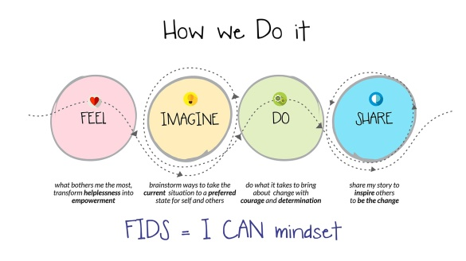

TASK: Watch the video and choose the best answer

1. According to Kiran what else is contagious?
a. Dream b. Laughter c. Work
2. What is the name of the bug Kiran talked about?
a. I can b. I win c. I will
3. What did Kiran study at college?
a. engineering b. design c. We don’t know
4. How did children learn about Children’s Rights?
a. They worked for eight hours b. They were told a story c. They watched a film
5. According to Kiran, children moved from…
a. “my teacher told me” to “I am doing it”.
b. “my teacher told me” to “I have to do it”.
c. “my teacher told me” to “she is doing it”.
6. According to Kiran, parents want to know that their child…
a. is having fun at school.
b. is having grades.
c. is doing great in Maths.
7. What does the city do every other month for children?
a. They give them toys.
b. They offer them space to play.
c. They close schools for one day.
8. The project at Riverside proved to be …
a. successful. b. easy to do. c. useful.
9. What did the children give to the city as a gift?
a. Flowers b. A flowery zebra crossing c. Love and smiles
10. How did kids from Riverside spread the bug?
a. they sent out a message b. they sent out a toolkit c. they sent out 100.000 emails

