What are the challenges people who live or work close to nature face?
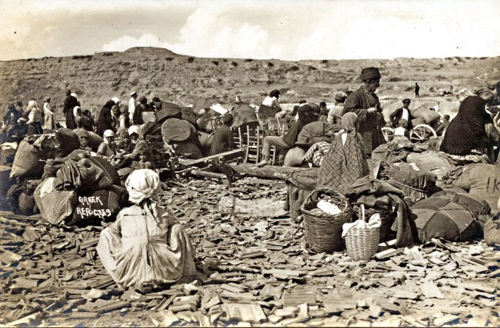
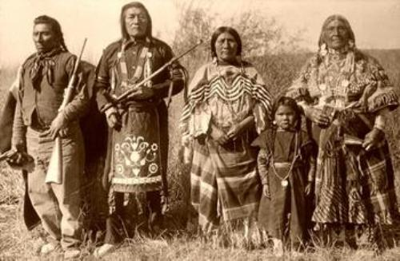

Step 1: Read and discuss the book extract for your group. Write down the challenges you think the people you examine faced in the right column.
Step 2: Work in pairs. Find a classmate from the other study group and share information. Write down the new information in the other column in your worksheet. Help your classmate fill in theirs.

The Mohawk people | The refugees from Asia Minor

Πηγές φωτογραφιών: https://thehistoryjunkie.com/mohawk-tribe-facts/ http://booksyros.blogspot.com/2015/11/blog-post_12.html

Extract 1: Bruchac, Joseph. The Bearwalker. New York: Harper Collins, 2007.
“…My uncle Jules told me about the Bearwalker. Long ago, he said, there was a Mohawk village. One day people began to disappear. They would go out hunting or to work in the fields and never return. Were enemies ambushing them? Was it some big animal that attacked silently and then carried off their bodies? No one knew. Then one day a hunter found something that filled him with fear. He ran back to the village to tell everyone. “I saw the tracks of a huge bear,” he said. “We have all seen bear tracks before” another hunter said. “What is so special about bear tracks?” “Ah,” the first man said, a shiver of fear going down his back as he spoke, “these were no ordinary tracks…”

Extract 2: Βενέζης Ηλίας. Γαλήνη. 1939.
“…Οι πατέρες τους και οι πρόγονοί τους ξέραν μονάχα τη γη, και πέρα από τα βουνά πάλι γη, χωρίς τέλος. Τους παρακολουθεί το χώμα σαν το αίμα στις φλέβες τους. Δεν ξέρουν τι θα πει ξεκούραση. Δουλεύουν, σκάβοντας, με το ένστιχτο του ζώου που γυρεύει καταφύγιο. Ξέρουν πως η γη που θα ξεχερσώσουν θα τους δώσει τροφή και σπόρο…”

